**Setting the Mouse Cursor Style**

CSS allows you to set your desired cursor style when you mouse over an element. For example, you can change your cursor into a hand icon, help icon, and much more, rather than using the default pointer.   
  
In the example below, the mouse pointer is set to a help icon when we mouse over the span element:<span style="cursor:help;">  
Do you need help?  
</span>

**The cursor Property Values**

There are numerous other possible values for the **cursor**property, such as:  
**default**- default cursor  
**crosshair**- cursor displays as crosshair  
**pointer**- cursor displays hand icon  
The list of possible values is quite long. The image below demonstrates the various available styles:

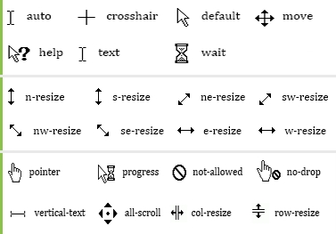

**The default Value**

Usually, the appearance of the mouse cursor is altered to provide a more interesting experience for website visitors. However, choosing the wrong cursor style can be misleading, as well.   
For example, if the cursor value is set to **default**, users may not "see" the links.

Choose your mouse cursor styles carefully.